**1.** **Posłuchaj dwukrotnie wywiadu dotyczącego życia w przyszłości. Dopasuj do obydwu osób ilustracje, które odpowiadają ich wizjom przyszłości.**

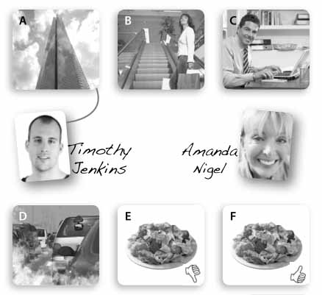

___/10

**2. Połącz fragmenty zdań. Jeden fragment jest zbędny.**

**a** sure he’ll come.

**1** I’ve got a sweet

**b** stand hot food.

**2** I don’t mind

**c** some cake?

**3** I’m

**4** I don’t really think

**d** some cake, please.

**5** I can’t

**e** perhaps.

**6** Would you like

**7** I’d like

**f** tooth.

**g** hot food.

**h** that’s a good idea.

___/7

**3. Zakreśl właściwe wyrazy. Otocz kółkiem prawidłową odpowiedź.**

**1** I’d like a _______ of orange juice, please.

**a** knife **b** glass **c** straw

**2** Can we have a ride in a _______ car?

**a** dodgem **b** slide **c** roller

**3** Lemons are yellow and _______.

**a** bitter **b** salty **c** sour

**4.** **Napisz, co przedstawiają ilustracje.**

At the funfair

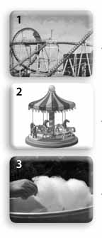 1. Ślizgawka 2 karuzela 3 wata cukrowa

_____________________

_____________________

_____________________

On the table

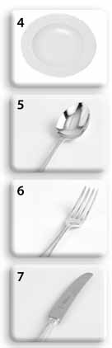

_____________________

_____________________

_____________________

_____________________

___/7

**5. Przetłumacz fragmenty zdań w nawiasach   
na język angielski.**

**1** Daphne wants to (*wyjść za mąż*) _______________ _________ soon.

**2** Trisha didn’t (*zbić fortunę*) ____________________.

**3** Emma should (*stać się sławnym*) ______________ __________ soon.

**4** Could you pass me your (*miskę*) ________, please?

..../ 4

**6.** **Ułóż zdania z podanych wyrazów.**

**1** you / he / phone / will /.

_________________________________________

**2** get / won’t / they / a medal / .

_________________________________________

**3** do / what / he / will / ?

_________________________________________

**4** what / say / I / should / ?

_________________________________________

**5** we / should / when / home / get / ?

_________________________________________

**6** won’t / she / come / back / .

_________________________________________

**7** the room / shouldn’t / she / leave / .

_________________________________________

___/7

**7.** **Przetłumacz fragmenty zdań w nawiasach na język angielski. Wykorzystaj czasowniki   
z ramki.**

eat arrive go visit study buy tell

**1** (*Odwiedzę*) __________________ you soon.

**2** She (*nie powie*) _________________ us the truth.

**3** (*Czy oni kupią*) _________________ a new house?

**4** (*O której przyjedziesz*) _______________________ ___________ in London?

**5** You (*powinienieś się uczyć*) ___________________

for tomorrow’s test.

**6** He (*nie powinien jeść*) _________________so much.

**7** Where (*powinienem iść*) _________________ now?

**8. Uzupełnij zdania wyrazami :)**

**wish envelope light invite   
name day**

**1** It’s my birthday tomorrow. I want to ________________ all my friends from school.

**2** I got a birthday card in a beautiful yellow ________________.

**3** Make a ________________ when you see a falling star.

**4** Is it your ________________ today?

**5** It’s dark in here. Can you ________________ the candles, please?

___/5